Samara Holmes
2/3/2025
Pattern Recognition & Computer Vision
Note: This is a day late because I got confused with being in the Eastern Time Zone for the Canvas submission
- Give an intuitive definition of the meaning of eigenvectors in the context of image analysis (think about the faces example).
Eigenvectors allow you do reduce the face images into a simpler form. You can also reconstruct faces using the eigenvectors. Say part of the image of the face is obscured, using the eigenvectors, you can approximate what should be there.
- You have the set of eigenvalues 0.3, 0.25, 0.24, 0.12, 0.06, 0.02, 0.01
  - What is the dimensionality of original data?
The dimensionality is 7 dimensions because there are 7 eigenvalues in the set.
  - How many dimensions of the data would you need to keep to represent 75% of the variation?
To represent 75% of the variation we only need the first 3 eigenvalues. This is because of the following:
0.3 + 0.25 + 0.24 + 0.12 + 0.06 + 0.02 + 0.01 = 1
0.3 + 0.25 + 0.24 = 0.79 which is greater than 75%
  - How many dimensions of the data would you need to keep to represent 90% of the variation?
0.3 + 0.25 + 0.24 + 0.12 + 0.06 + 0.02 + 0.01 = 1
0.3 + 0.25 + 0.24 + 0.12 = 0.91 which is greater than 90%
  - If you wanted to see best visualization of the data in 2-D, how would you do it?
To get the best visualization of the data in 2-D, you can use Principal Component Analysis for dimensionality reduction. Where you would need to get the eigenvectors and eigenvalues of the covariance matrix of the data. Then get the top K eigenvectors with the highest eigenvalues, then project the original data onto the K eigenvectors.
- Find an example of aliasing in visual media. It can be spatial, temporal, or spectral aliasing. Include either a link to your example or the example itself in your submission, along with a description.
Aliasing is where signals are sampled at a rate too slow to capture the real frequency.
https://www.dpreview.com/videos/7451772453/this-is-what-happens-when-your-camera-s-frame-rate-matches-a-bird-s-wing-flap
This is a YouTube video I saw a while back, and it is an example of aliasing. A hummingbird wing flap can be up to 80 times per second, however, in this footage, the bird is said to be flapping at approximately 20 frames per second. This supposedly matched the speed of the security camera, making the bird appear as if it were floating.
- Select two different textures and use your project 1 program to show the gradient magnitude for each texture. Would average energy of gradient magnitude be a useful feature for differentiating these two images?
I did the gradient magnitude of the Laplacian and the Gaussian Blur.
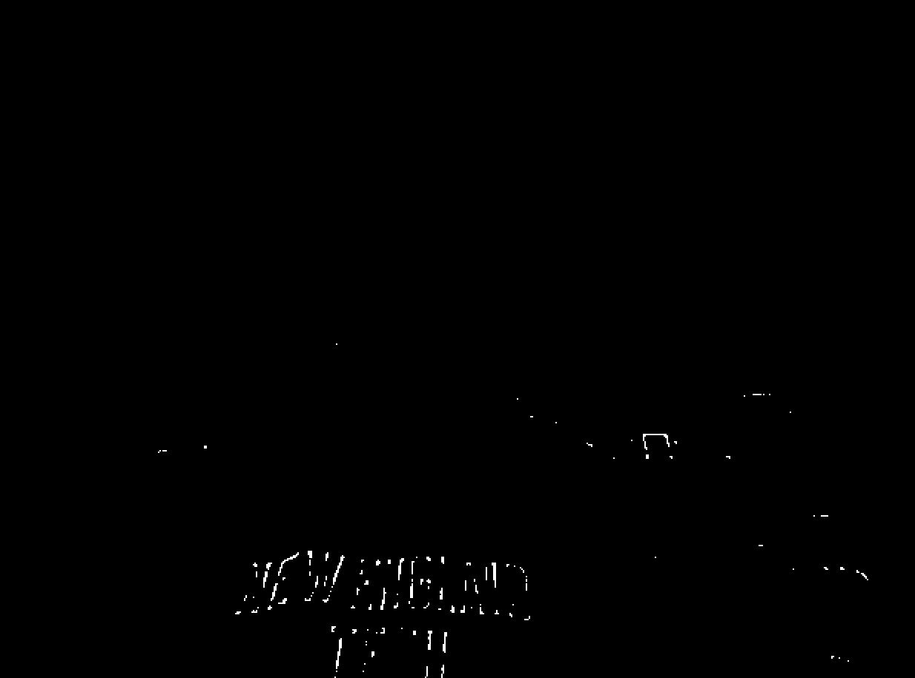
The average energy of the gradient magnitude may be useful because it would provide info on how much texture or edge info is in the image. Textures with more edges would generally have higher gradient magnitudes.
- When using Law's texture filters, why do you think it is helpful to divide the responses by the Gaussian filter (L5 x L5)?
It is helpful to divide the responses by the Gaussian filter because then the responses are normalized. Normalizing the responses helps in removing image artifacts and reduces the noise, making the texture analysis more consistent.

